For Rent
1488 Villa Piña Way #201

2 bed 1.5 bath 900ft²
$1,550 per month
Spanish-style condo in great location
Won’t last! Available June 1

Contact Claire Vasquez @ (double-check cell #)
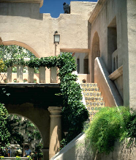
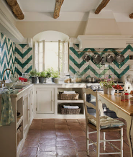
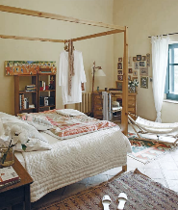
ABOUT VILLA PIÑA
Beautiful grounds
Dine-in kitchen
Spacious bedrooms

Private but centrally located, historic Villa Piña is just moments from fine dining, shopping, and public transportation. Enjoy the best of both worlds at Villa Piña—the beauty of nature and the culture of a vibrant neighborhood.

For more information, visit us online:
www.villapinacondos.com

For Rent
1502 Villa Piña Way #103

1 bed 1 bath 750ft²
$850 per month
Spanish-style condo in great location
Won’t last! Available August 1st

Contact Juanita Vasquez @ (919-555-7237)
ABOUT VILLA PIÑA
Beautiful grounds
Dine-in kitchen
Spacious master

Private but centrally located, historic Villa Piña is just moments from fine dining, shopping, and public transportation. Enjoy the best of both worlds at Villa Piña—the beauty of nature and the culture of a vibrant neighborhood.

For more information, visit us online:
www.villapinacondos.com

